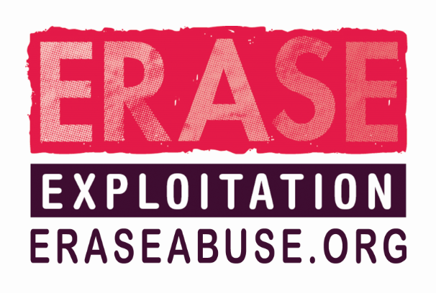**CSE Intelligence / Information Submission Form 2016**

**If you have concerns about a child / young person you should make a referral to your local children’s services. DO NOT USE THIS FORM IN PLACE OF A REFERRAL.**

Please complete this form to share any information you have about:

* Suspected offenders
* Suspected vehicles
* Locations of interest

|  |  |
| --- | --- |
| THIS INFORMATION WILL NOT BE RECORDED ON POLICE SYSTEMS | |
| NAME: |  |
| POST / POSITION: |  |
| EMAIL: |  |
| TELEPHONE NO.: |  |

|  |  |
| --- | --- |
| THIS INFORMATION IS RECORDED ON POLICE SYSTEMS | |
| AGENCY: |  |

|  |
| --- |
| INFORMATION |
| Please supply all known information in as much detail as possible, including:  Date(s), Time(s), Person(s), Vehicle(s), Location(s)  If you only have partial details such as a colour and model of the vehicle please include this information as it helps us build a picture. |
| Please enter your information here: *(this box will expand as you type)* |

**THIS SECTION MUST BE COMPLETED**

|  |  |  |  |  |  |
| --- | --- | --- | --- | --- | --- |
| INFORMATION EVALUATION | | | | | |
| SOURCE OF INFORMATION:  If the information was supplied by someone else, how reliable are they? | **1 RELIABLE –** Person known to me and known to tell the truth  **2 UNTESTED –** Person known but cannot test how reliable they are i.e. never given information before or person unknown/heard indirectly and cannot be judged.  **3 UNRELIABLE –** Person known to me but known not to be truthful. | | | | **ENTERED YOUR RATING HERE:** |
| INFORMATION ACCURACY: | **A - KNOWN TO BE TRUE TO SOURCE**  **B -** **INFORMATION WHICH HAS BEEN OVERHEARD OR TOLD TO YOU BY SOMEONE ELSE**  **D - NOT KNOWN**  **E - SUSPECTED TO BE FALSE** | | | | **ENTERED YOUR RATING HERE:** |
| DATE OF SUBMISSION: | |  | **TIME OF SUBMISSION:** |  | |

**PLEASE RETURN YOUR COMPLETED FORM TO:** [**ERASE@durham.pnn.police.uk**](mailto:ERASE@durham.pnn.police.uk)